***Experiment 1***

**Aim:** Students will learn to understand the basics of cloud computing by setting up and configuring a virtual machine on a cloud platform such as AWS, Google Cloud, Microsoft Azure or localstack.

***Running Docker***

***Running Localstack***

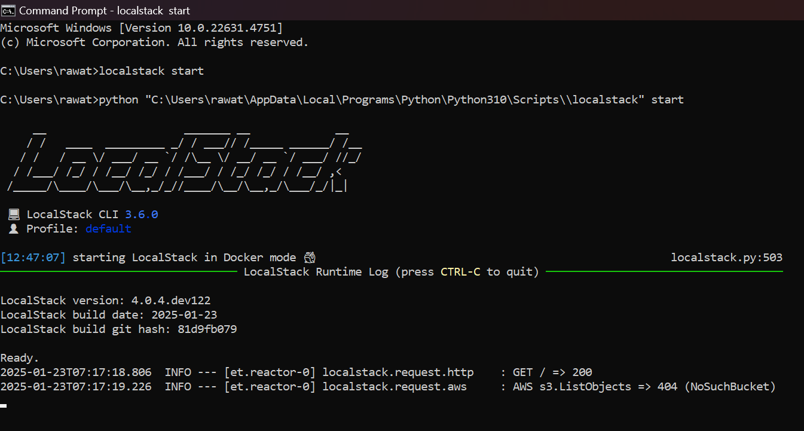

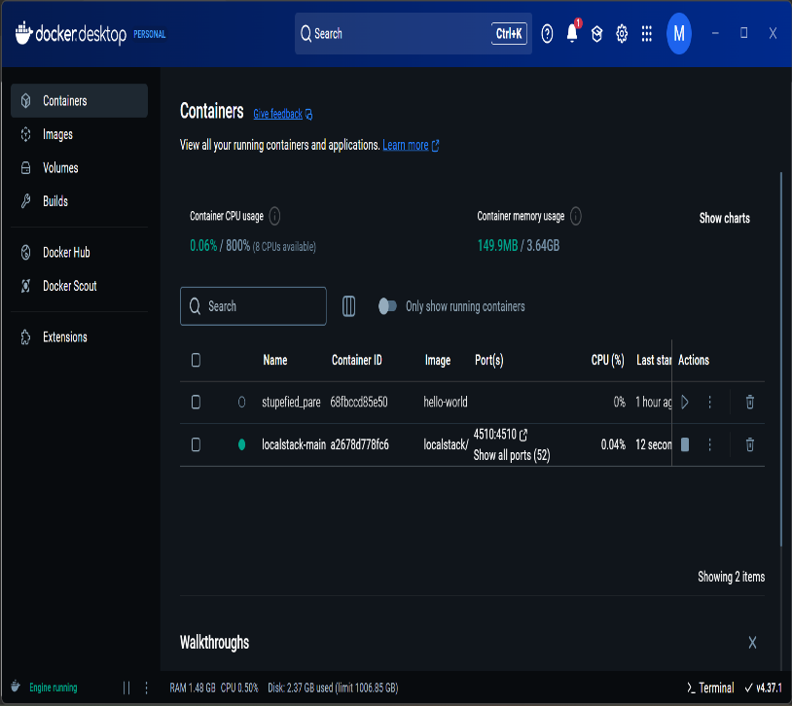

***Fig 2: Docker for Desktop in windows***

***Creating a New Instance***

**Fig 1: Starting Localstack in the Console**

***Starting Virtual Machine***

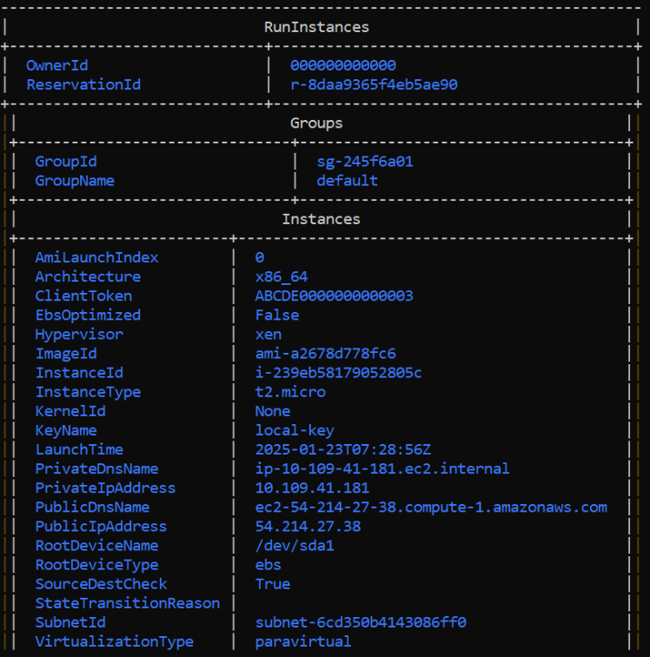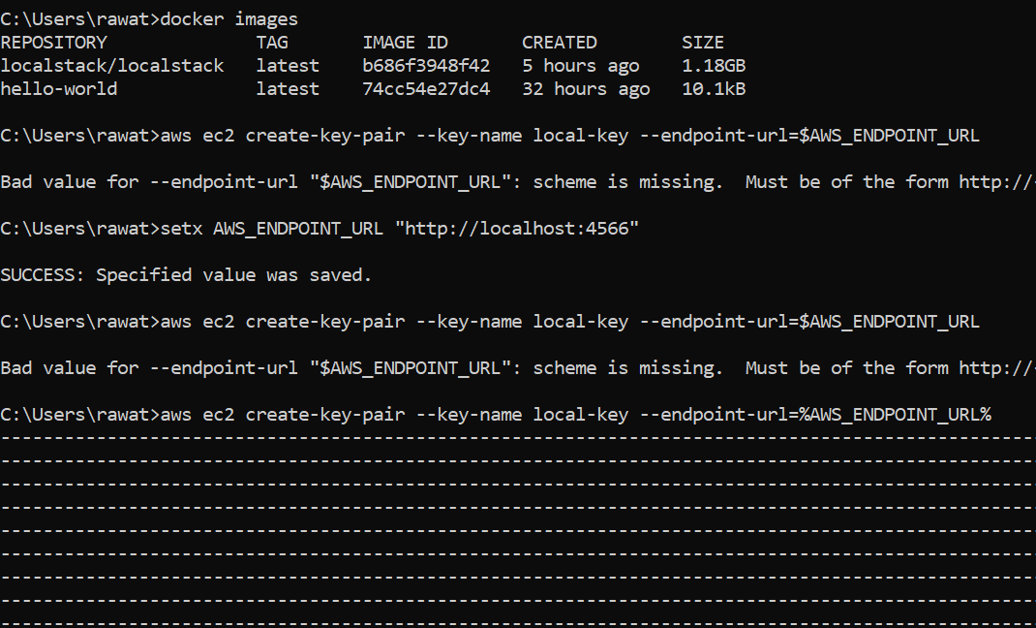

***Fig 3: Docker Images and New Instances***

***Fig 4: Virtual Machine & Working***